NATIONAL UNIVERSITY OF MODERN LANGUAGE ISLAMABAD
Lab final


Submitted to:
Mr. Danish
Submitted by:
Zulqarnain Hassan
Roll No: …………………… SP21379
Subject: …………………… WEB II
Department: ……………… BSSE-7-Afternoon
Date: ……………………… 23-12-2026

Task 1: Frontend State Management Using React
import React, { useState, useEffect } from 'react';

function App() {
const [products, setProducts] = useState([]);
const [name, setName] = useState("");
const [price, setPrice] = useState("");

// URL of your Express API
const API_URL = "http://localhost:5000/api/products";

// TASK 3: Fetch products from Backend on load
useEffect(() => {
fetch(API_URL)
.then(res => res.json())
.then(data => setProducts(data))
.catch(err => console.error("Error fetching data:", err));
}, []);

// TASK 4: POST a new product to MongoDB via Backend
const addProduct = async () => {
const newProduct = { name, price: Number(price), category: "Jewelry" };

const response = await fetch(API_URL, {
method: "POST",
headers: { "Content-Type": "application/json" },
body: JSON.stringify(newProduct)
});

if (response.ok) {
// Refresh list after successful save
const updatedData = await response.json();
setProducts([...products, newProduct]);
setName(""); setPrice("");
}
};

return (
<div style={{ padding: '40px' }}>
<h1>Jewelry Inventory Management</h1>

<div className="form">
<input placeholder="Product Name" value={name} onChange={e => setName(e.target.value)} />
<input placeholder="Price" type="number" value={price} onChange={e => setPrice(e.target.value)} />
<button onClick={addProduct}>Add to Inventory</button>
</div>

<hr />

<h2>Current Stock</h2>
<ul>
{products.map((p, index) => (
<li key={index}>{p.name} - ${p.price}</li>
))}
</ul>
</div>
);
}

export default App;

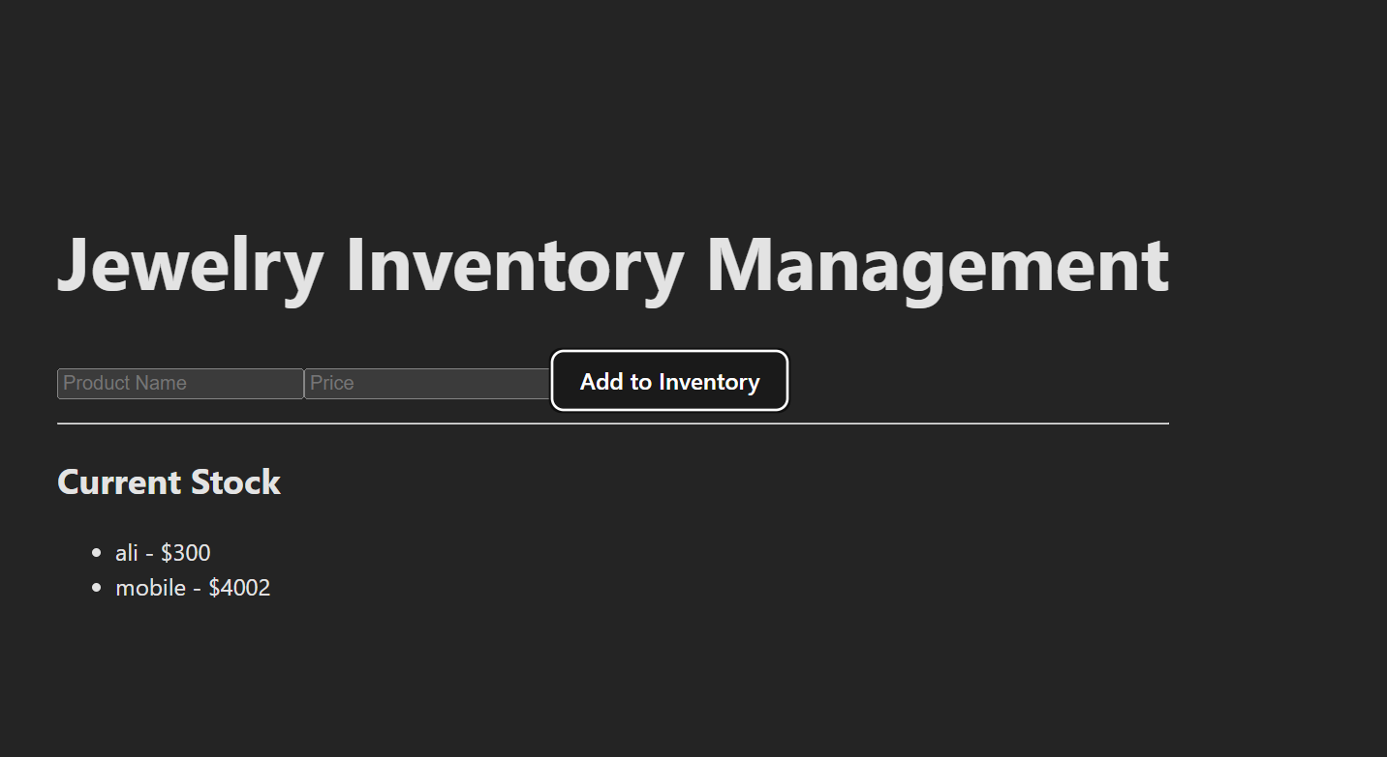
Task 2: Backend Development Using Node.js and Express.js
import express from 'express'
import mongoose from'mongoose';
import cors from 'cors';

const app = express();
app.use(express.json()); // Middleware to parse JSON
app.use(cors()); // Allows frontend to talk to backend

// Connect to MongoDB
mongoose.connect('mongodb://localhost:27017/jewelryDB')
.then(() => console.log("Connected to MongoDB"))
.catch(err => console.error(err));

// Task 4: Define Jewelry Product Schema (Flexible Document Structure)
const ProductSchema = new mongoose.Schema({
name: String,
price: Number,
category: String, // e.g., "Ring", "Watch"
details: Object // Flexible field for different product specs
});

const Product = mongoose.model('Product', ProductSchema);

// Task 3: RESTful Endpoints
app.get('/api/products', async (req, res) => {
const products = await Product.find();
res.json(products);
});

app.post('/api/products', async (req, res) => {
const newProduct = new Product(req.body);
await newProduct.save();
res.json({ message: "Product added!" });
});

app.listen(5000, () => console.log("Server running on port 5000"));

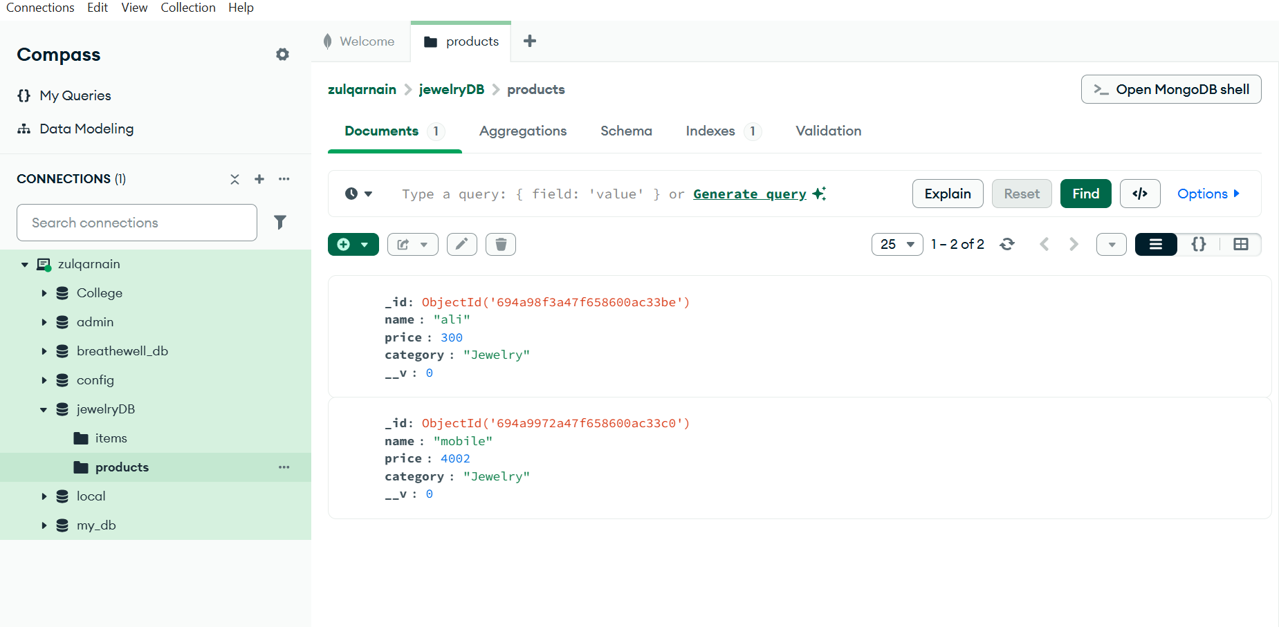
Task 3: Express.js Routing and Middleware Implementation

const app = express();
app.use(express.json()); // Middleware to parse JSON
app.use(cors()); // Allows frontend to talk to backend

Task 4: MongoDB CRUD Operations for Jewelry Products
const ProductSchema = new mongoose.Schema({
name: String,
price: Number,
category: String, // e.g., "Ring", "Watch"
details: Object // Flexible field for different product specs
});

const Product = mongoose.model('Product', ProductSchema);

// Task 3: RESTful Endpoints
app.get('/api/products', async (req, res) => {
const products = await Product.find();
res.json(products);
});

app.post('/api/products', async (req, res) => {
const newProduct = new Product(req.body);
await newProduct.save();
res.json({ message: "Product added!" });
});
